**Association Rules**

Following are a few interesting association rules that we churned out of our data using apriori rules.

lhs rhs support confidence lift

[1] {Compensation=More than $160,000,

Industry=Finance / Banking} => {Exp=11+ years} 0.005288917 0.8375000 2.835235

[2] {Country=United States,

Compensation=More than $160,000} => {Exp=11+ years} 0.013024945 0.8505155 2.879297

[3] {Exp=Less than 1 year,

Country=India,

Industry=Software Products} => {Compensation=Less than $20,000} 0.006630881 0.8155340 3.872258

[4] {Exp=2 - 5 years,

Country=India,

Occupation=Full-stack web developer,

Industry=Software Products} => {Compensation=Less than $20,000} 0.005525734 0.8139535 3.864754

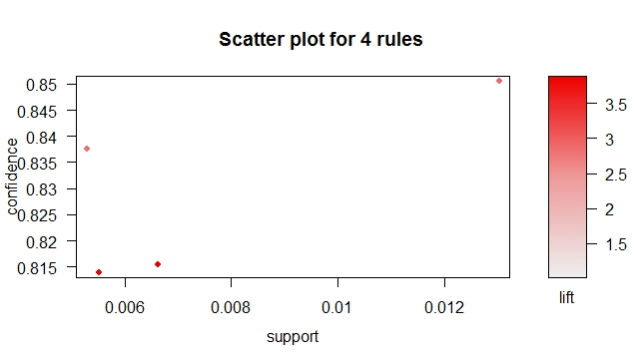

Association Rules for “Not Interested in Job Opportunities”

[1] {Country=United States,

Age=35-39,

Job.Satisfaction=I love my job} => {Open.to.new.job.opportunities=I am not interested in other job opportunities} 0.008213985 0.6763006 2.146919

[2] {Country=United States,

Compensation=$100,000 - $120,000,

Job.Satisfaction=I love my job} => {Open.to.new.job.opportunities=I am not interested in other job opportunities} 0.009126650 0.6666667 2.116336

[4] {Age=30-34,

Compensation=$60,000 - $80,000,

Job.Satisfaction=I love my job} => {Open.to.new.job.opportunities=I am not interested in other job opportunities} 0.007862960 0.6549708 2.079207

[5] {Country=United Kingdom,

Age=25-29,

Job.Satisfaction=I love my job} => {Open.to.new.job.opportunities=I am not interested in other job opportunities} 0.006318450 0.6521739 2.070329

[18] {Country=Sweden,

Job.Satisfaction=I love my job} => {Open.to.new.job.opportunities=I am not interested in other job opportunities} 0.005054760 0.6101695 1.936986

Association Rules for Compensation in range of $20K-40K

lhs rhs support confidence lift

[1] {Country=Spain,

Occupation=Full-stack web developer,

Industry=Software Products} => {Compensation=$20,000 - $40,000} 0.001736659 0.6285714 3.893762

[2] {Exp=11+ years,

Country=Poland,

Industry=Software Products} => {Compensation=$20,000 - $40,000} 0.001026208 0.6190476 3.834765

[3] {Exp=6 - 10 years,

Country=Spain,

Occupation=Full-stack web developer} => {Compensation=$20,000 - $40,000} 0.002131355 0.6136364 3.801245

Association Rules for Freelance Folks

[2] {Compensation=More than $160,000,

Industry=Consulting,

Job.Satisfaction=I love my job} => {Employment.Status=Freelance / Contractor} 0.001301448 0.8000000 7.200000

[3] {Years=11+ years,

Compensation=More than $160,000,

Industry=Consulting,

Job.Satisfaction=I love my job} => {Employment.Status=Freelance / Contractor} 0.001138767 0.7777778 7.000000

Association Rules for People who Program 5-10 hours per week

[1] {Occupation=Mobile developer,

Industry=Consulting} => {Prgm.Hours=5-10 hours per week} 0.001057426 0.5652174 2.467607

Association Rules for People who Program 2-5 hours per week

[1] {Country=Finland,

Occupation=Full-stack web developer,

Compensation=$40,000 - $60,000} => {Prgm.Hours=1-2 hours per week} 0.001057426 0.6190476 2.954414

[2] {Years=11+ years,

Occupation=Desktop developer,

Compensation=$80,000 - $100,000,

Job.Satisfaction=I'm somewhat satisfied with my job} => {Prgm.Hours=1-2 hours per week} 0.001138767 0.5600000 2.672609

Association Rules for Job Lovers

[1] {Country=Netherlands,

Employment.Status=Freelance / Contractor} => {Job.Satisfaction=I love my job} 0.002440215 0.7500000 2.191704

[2] {Years=11+ years,

Employment.Status=Other} => {Job.Satisfaction=I love my job} 0.003009598 0.7254902 2.120080

Association Rules for Job Haters

[1] {Years=6 - 10 years,

Occupation=Back-end web developer,

Employment.Status=Employed full-time,

Prgm.Hours=10-20 hours per week} => {Job.Satisfaction=I hate my job} 0.0004067025 0.1470588 7.117879

[2] {Years=6 - 10 years,

Occupation=Back-end web developer,

Prgm.Hours=10-20 hours per week} => {Job.Satisfaction=I hate my job} 0.0004880429 0.1304348 6.313249

[3] {Country=United States,

Occupation=Student} => {Job.Satisfaction=I hate my job} 0.0004067025 0.1190476 5.762092

[4] {Employment.Status=Employed full-time,

Industry=Finance / Banking,

Prgm.Hours=20+ hours per week} => {Job.Satisfaction=I hate my job} 0.0004067025 0.1162791 5.628090

Association Rules for 20+ hours/week programmers

[1] {Years=2 - 5 years,

Compensation=Rather not say,

Employment.Status=Freelance / Contractor} => {Prgm.Hours=20+ hours per week} 0.001301448 0.3636364 4.859289

[2] {Occupation=Mobile developer - Android,

Compensation=Less than $20,000,

Industry=Software Products,

Job.Satisfaction=I love my job} => {Prgm.Hours=20+ hours per week} 0.001301448 0.3478261 4.648015

[3] {Employment.Status=Freelance / Contractor,

Industry=Gaming} => {Prgm.Hours=20+ hours per week} 0.001057426 0.3421053 4.571568

[4] {Years=2 - 5 years,

Employment.Status=Freelance / Contractor,

Industry=Web Services,

Job.Satisfaction=I love my job} => {Prgm.Hours=20+ hours per week} 0.001057426 0.3421053 4.571568

[5] {Years=2 - 5 years,

Occupation=Mobile developer - Android,

Compensation=Less than $20,000,

Employment.Status=Employed full-time,

Industry=Software Products} => {Prgm.Hours=20+ hours per week} 0.001057426 0.3421053 4.571568

Association Rules Over Languages

[1] {Hadoop=N,

Haskell=N,

Node.js=Y,

Spark=N} => {JavaScript=Y} 0.09633520 0.9114980 1.987739